TASK LAB 2

Name : Zaryab

Roll Num : BSCS/S17/0109

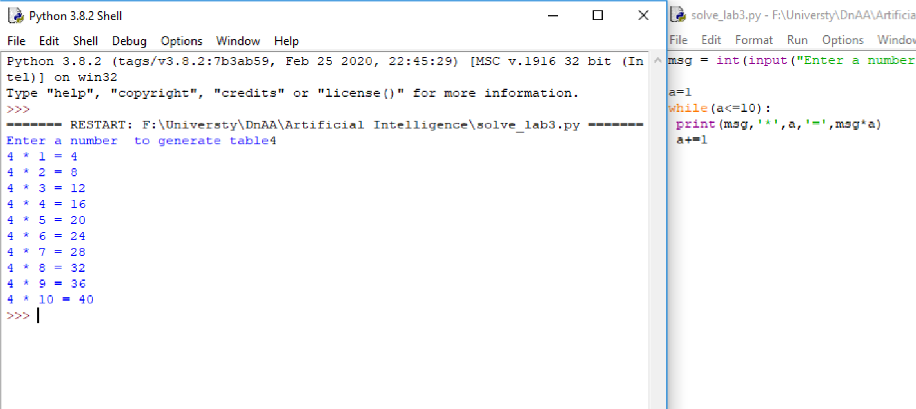CMS ID : 293-2017

TASK 1

1. Generate Table of the user entered number

TASK 2

1. 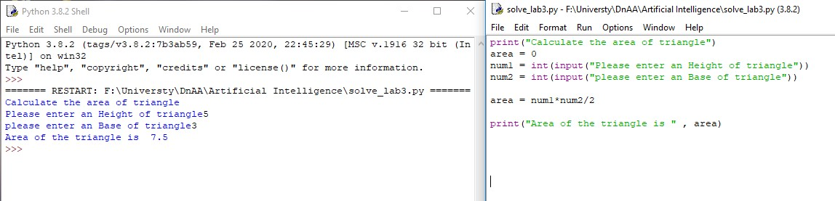Write a program to implement simple calculator

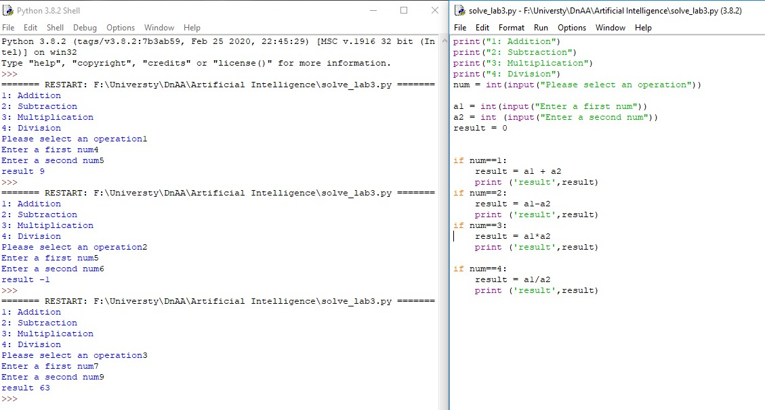

TASK 3

1. Write a code to calculate area of triangle.

TASK4

1. Write python program to sort words in alphabetical order. Your program should take a

sentence as input from user. Then sort the words of the sentence in order.

